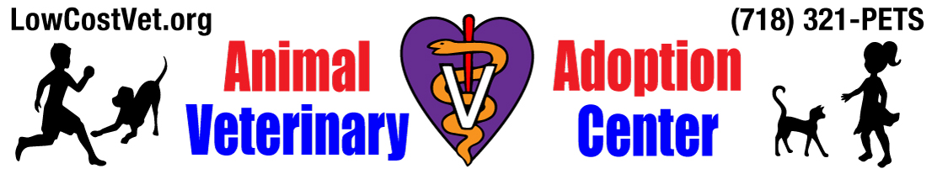
IN ORDER TO BE CONSIDERED AS AN ADOPTER , YOU MUST:
- Be 18 years of age or older;
- Have identification showing your present address;
- Have the knowledge and consent of your landlord;
- Be able and willing to spend the time and money necessary to provide training, medical treatment, and proper care for a pet.
Donation: Kittensor puppies: $150 for one, $200 for two;
Adults: $125 for one, $175 for two or 150 for a mandatory “couple”
Seniors/special needs: $100 for one $150 for two.

I understand that damages for my non-compliance of this contract will be assessed for expenses incurred by __________________________________ in making this adoption possible, calculated as liquidated damages in the sum of $1800, and that the animal will not be treated as chattel for legal purposes, but as a victim of pain and suffering.

The animals available for rehoming come to us from a variety of sources. All animals are examined by a licensed veterinarian. I have been given a copy of the animal’s medical records.

In the event an accident or any harm or illness befalls said animal, such as losing it, an accident, etc., I agree to immediately seek medical care at __________________________________ or obtain veterinary care elsewhere and authorize the release of all veterinary records to ____________________________ and notify _________________________________ within 24 hours of such event by telephone as to the name, address and telephone number of treating veterinarian or hospital and date, time, location, and nature of loss, or accident. In the event of any other changes such as behavioral issues of the animal or other household members or illness or loss of animal or any lifestyle changes, I agree to expand costs and efforts to treat and/or solve the issue(s) and/or retrieve said animal, including, but not limited to free obedience training, veterinary care, searching, advertising, printing and posting of flyers, gasoline, and labor and other costs, up to a maximum of $1,500. My failure to abide with this paragraph's notification, veterinary care, obedience training and other requirements shall subject me to the expenses incurred by any party to provide the required services, as specified above, in addition to the liquidated damages agreed to in Section 1 of this Contract and Agreement, if applicable.

An identification tag a collar will be kept on this pet continuously and at all times and will never be walked off leash unless in a closed 6ft fenced area with no holes or a City Park designated off leash area during off leash hours. I understand that this animal is not being bought, and that _____________________________________ reserves the right to repossess it upon demand.

I agree to notify ___________________________________ of any new residence address and/or telephone number which I may acquire within thirty (30) days of such acquisition.

I agree not to hold _____________________________________, nor placing party from whom animal was obtained, liable not responsible in any manner, for harm or damages which may result after my possession of said animal.

If, at any time during the entire life span of this animal, I can no longer keep and provide for said animal, I agree to notify ________________________________ a minimum of 90 days prior to being unable to keep said animal and keep it until another permanent home is found who will sign _____________________________’s adoption agreement. If I am unable to keep the animal until a new home is found I agree to board the animal at my expense until a permanent home is found. Under no circumstances will I give this pet to a person, shelter or abandon it. I understand that the animal is not my property to transfer to any other person or entity.

I understand that _________________________________ reserves the option of taking the animal back at anytime for cause of violation of this agreement and that the adoption fee will not be refunded.

- Adoption Donation is non refundable, except under extraordinary circumstances at our sole discretion. If any portion of this contract is found unenforceable, the balance shall remain in full force and effect.

______________________________ ______________________________
Signature of Accepting party Employer of Accepting party

______________________________ ______________________________
Printed name of Accepting party Employer's address

_____________________________
Employer's telephone

______________________________ ______________________________
Telephone of Accepting Party Family Reference Name

______________________________ ______________________________
Street Address of Accepting party Family Reference address

______________________________
Family Reference Phone Number

__________________________________ ______________________________
City State Zip Code Accepting Party's date of birth

______________________________ ______________________________
Printed name of witness Breed of animal being accepted

______________________________ _________________________ ______
Signature of witness Approximate age of animal Gender

______________________________ ______________________________
Street Address of witness Name of accepted animal

______________________________ ______________________________
Telephone of witness Microchip ID#

______________________________ ______________________________
Date of this agreement ID type and Identifying number

On this date of __________________________, I, ________________________________ obtained

possession of above mentioned animal from the placing party,

__________________________________________. _______________________________
Signature

